

www.kidzcancode.com

Whack A Mole

kidzcancode

trevor warren

2018

# Safety Warnings

THE MICRO:BIT IS AN EXPOSED BOARD, TO BE USED WITH CARE PLEASE RETAIN THIS INFORMATION FOR FUTURE REFERENCE. You can read the detailed document at - <http://microbit.org/guide/safety-advice/>

# General Safety Warnings

Using the BBC micro:bit is easy to use but is designed to have all the electrical parts on display. This does mean there's a small risk that the parts can be damaged and even overheat with a risk of injury but a little bit of care and caution will ensure you and your micro:bit will stay fit and healthy.



1. Always keep your BBC micro:bit in the anti-static bag when not in use. It's good practice for students to earth themselves before handling it.
2. Please handle your BBC micro:bit by its edges. This minimises the risk of damage through an electrostatic discharge.
3. Please use the battery pack and the USB lead provided to power your micro:bit. Do not use portable battery chargers or USB charging ports (often marked with a lightning bolt or 'SS'), to power your micro:bit. Using these may damage your micro:bit and stop it working properly.
4. Please avoid handling the BBC micro:bit circuit board while plugged into a power supply.
5. All peripherals (for example: USB cable, battery holder, sensors) used with your BBC micro:bit should comply with the relevant standards and should be marked accordingly.
6. Connecting your BBC micro:bit to any unapproved peripherals could damage your BBC micro:bit
7. Please do not attempt to keep using faulty micro:bits. If a school-issued micro:bit develops a fault, contact the vendor immediately.
8. The maximum current safely supplied to an external circuit using the 3V pin on the edge connector is 100mA. Please make sure this limit is not exceeded.
9. Please do not store or use your BBC micro:bit in extremely hot or cold environments.
10. Do not place any metal objects across the printed circuits on the board as this can cause a short circuit damaging your BBC micro:bit. This can cause risk of burn or fire.
11. Do not use your BBC micro:bit in water or with wet hands.
12. Do not leave your BBC micro:bit plugged into a computer or any other device unsupervised.
13. Please do not leave your BBC micro:bit within reach of children under 8 years of age.
14. Please operate your BBC micro:bit in a well ventilated room To remove the battery pack, pinch the connector with your fingers. Do not remove by pulling the wires.

# Battery Warnings



1. Do not try to charge normal (non-rechargeable) batteries
2. Please do not mix different types of batteries or mix new and used batteries.
3. Please use batteries of the same or equivalent type as those recommended.
4. Please insert batteries the correct way round (with the correct polarity).
5. Please remove spent batteries from the battery holder.
6. Do not short-circuit the battery supply terminals, for example by placing a metal object across the terminals.
7. Only use Zinc or Alkaline batteries with your BBC micro:bit.
8. Please do not use rechargeable batteries

# Pre-requisites

If you have questions with the assembly of the micro:bit, edge connector breakout board, mounting board and the breadboard please drop us a note at help@kidzcancode.com. The edge connector board, mounting board and the breadboard are part of the Kitronix Inventors kit which needs to be purchased separately.

To be able to perform this tutorial you will need the following components –

1. Parts required –
   1. 1 x BBC Micro:bit
   2. 1 x Mounting Plate
   3. 1 x Edge connector breakout board
   4. 1 x Bread board
2. Assembly required –
   1. Bread board mounted on top of the mounting plate
   2. BBC Micro:bit inserted into the Edge Connector breakout board

# C:\Perf\Personal\Github\CoderDojo\Images\Hi_Res_BBC_Microbit.jpg

Before proceeding please check your setup and confirm that all the required parts are configured as demonstrated in the above picture.

# Learning Objectives

The objectives of this tutorial are to introduce the student to the following concepts –

* Use of plot and unplot commands to LED’s on and off across the board
* Understanding the use of custom functions for purposes of programming
* Declaring variables and assigning values to variables at different times of execution in the program
* Coding for use of the buttons on the micro:bit, perform a given action when a button is pressed.
* Understand the importance of loops and decision-making statements. Implement them in the program.
* Learn how to use logical comparators in programs

The BBC micro:bit is a powerful little computer. Through programming these games kids explore more advanced computer science concepts. Along the way kids are encouraged to share, create and extend the games using their own imagination and creativity.

This tutorial builds upon concepts introduced in previous tutorials so please make sure you have covered the previous tutorials before you dive into this one. So overall this tutorial intends to build upon concepts learnt in previous tutorials while exploring new concepts.

In future tutorials we will continue to build upon the concepts learned here and will build more complex interactive games using the functionality provided by the micro:bit.

# Activity

# Activity

This activity involves designing a classic game called, “Whack A Mole”. Whack-a-mole is a popular arcade game invented in 1976 by Aaron Fechter of Creative Engineering, Inc.. A typical Whac-A-Mole machine consists of a large, waist-level cabinet with five holes in its top and a large, soft, black [mallet](https://en.wikipedia.org/wiki/Mallet).

Each hole contains a single plastic [mole](https://en.wikipedia.org/wiki/Mole_(animal)) and the machinery necessary to move it up and down. Once the game starts, the moles will begin to pop up from their holes at random. The object of the game is to force the individual moles back into their holes by hitting them directly on the head with the mallet, thereby adding to the player's score. The more quickly this is done the higher the final score will be.



The aim of the game is to use a mallet to strike a mole within a certain time. Moles randomly appear for a short time above a hole. As we will be using the micro:bit, our game will consists of two holes and two moles. The player will strike a mole by pressing the A or the B button on the micro:bit depending on whether the mole appears on the left or the right hand side of the LED screen.

See the picture below. The **!** represents a mole on the left hand side, The player has less than 1 second to whack this mole by pressing the A button.

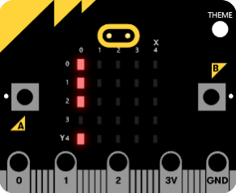

# How Does It Work

This section talks about the BBC micro:bit and what it’s made up of. If you have already read through this section then feel free to skip directly to the next section. The BBC micro:bit is a powerful little board and has various types of sensors on board. Here’s what makes up the BBC micro:bit.

1. Size: approx. 5cm x 4cm.
2. Weight: 8g.
3. Processor: 32-bit ARM Cortex M0 CPU.
4. Bluetooth Low Energy.
5. Digital Compass.
6. Accelerometer.
7. Micro-USB controller.
8. 5x5 LED matrix with 25 red LEDs.
9. Pins for connecting external sensors, LED’s, etc.

Here’s what the micro:bit looks like –



**Front of the board (left hand side)**

1. Button A (left button with edge connector at the bottom) – labelled A on the board
2. Button B (right button with edge connector at the bottom) – labelled B on the board
3. P0 (left large pin (crocodile clip port) with edge connector at the bottom) - labelled 0 on the board
4. P1 (middle large pin (crocodile clip port) with edge connector at the bottom) - labelled 1 on the board
5. P2 (right large pin (crocodile clip port) with edge connector at the bottom) - labelled 2 on the board
6. +3V - labelled 3V on the board. This is 3V PWR OUT
7. GND
8. P3 – P22 pins from left to right with edge connector at the bottom. Referred to as Pins when referencing that part of the board. Text will talk about 'pins' when referring to individual connections or the general way of connecting to the board – not labelled on the front of the board
9. LED matrix referred as the 'screen' - not labelled on the board
10. LED coordinates starting at 0,0 top left corner and ending at 4,4 at the bottom corner - not labelled on the board

The order of the large pins as follows: P0 P1 P2 3V GND labelled 0, 1, 2, 3V GND on the board

**Rear of the board (Right hand side)**

1. 1. USB Plug (Micro-USB plug) – labelled USB on the board
2. Button R (reset button) – labelled Reset on the board
3. Status LED – not labelled on the board
4. Battery socket – labelled Battery on the board

**Other components on the board include**

1. Accelerometer  
2. Compass  
3. Bluetooth Smart Technology Antenna  
4. AAA Battery Holder - not labelled on the board  
5. Processor (Cortex M0)

The BBC micro:bit is programmable in a few different languages. You can write code for the micro:bit using the Makecode block coding interface, Javascript, Python of even in C. Most of our tutorials will cover the use of the Makecode block coding interface built by Microsoft for the micro:bit.

# Let’s write some code

It’s time to write some code and get going with coding our game. So let’s head over to the micro:bit block code editor page (<https://makecode.microbit.org/>) and get coding!!!

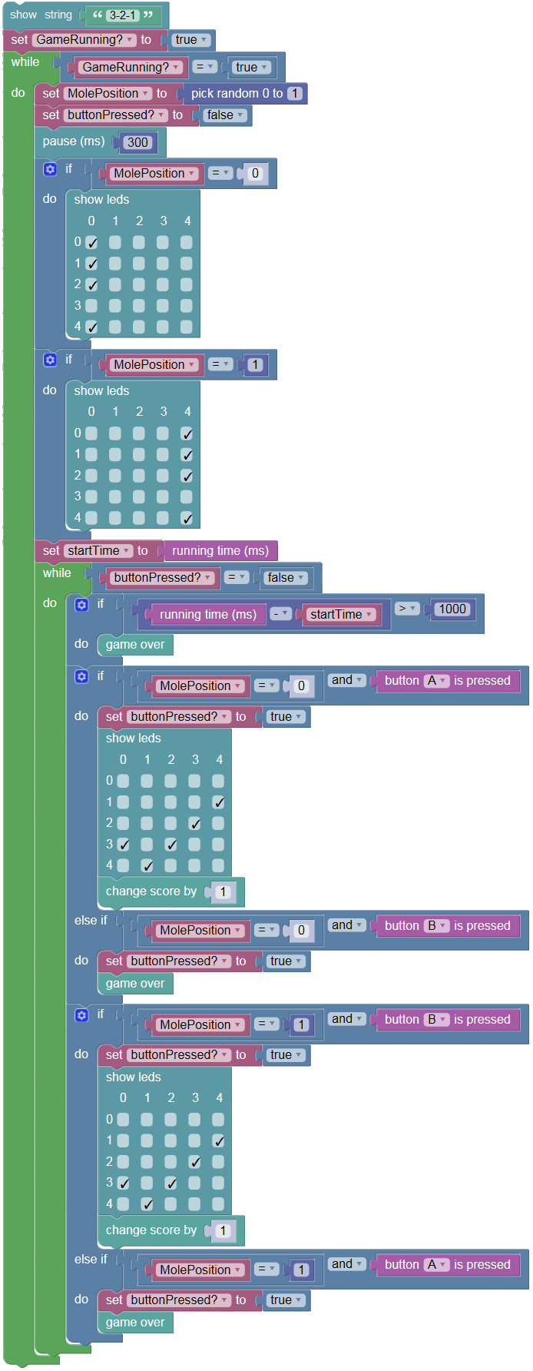

You are encouraged to make changes, improvise and customize the game using your own ideas.

# Question Time

Let’s use this opportunity to go over the questions below and validate our understanding of the different code segments. Could you identify which section of code is used to -

1. Randomly display a mole to either the left or the right of the screen?
2. Check, if the left mole is displayed, that the user has pressed button A and if not ends the game?
3. Check, if the right mole is displayed, that the user has pressed button B and if not ends the game?
4. Allow a maximum of 1 second for the user to whack a mole? If the use exceeds this delay, the game should end.

You are encouraged to make changes, improvise and customize the game using your own ideas.

# Downloading Your Code To The micro:bit

Once you have completed the program, enter a name for your program using the option provided below i.e. in the text box adjacent to the small save button.



Now that you have given your program a name and saved it you can download it your micro:bit. But before we do that let’s confirm what drive your micro:bit shows up as. On most machines the micro:bit will show up as an additional USB drive. So head over into windows explorer and confirm what drive name (D:, E:, F:. G:, etc. ) the micro:bit shows up as. You need to absolutely be sure what drive the micro:bit shows up as. Once you’ve confirmed what drive the micro:bit shows up as on your machine you can select the right drive when downloading the code to the micro:bit. If in doubt please ask the volunteer/mentor/session facilitator helping out.



To download the newly written code to the micro:bit, hit the download button shown above. You should now see a dialog box open up and you will be asked to save the file somewhere on your machine. Please choose the drive your micro:bit shows up as i.e. D: or E: or F: or whatever it shows up as on your machine. A sign of success is when you see the lights on the rear (orange) lighting up in quick succession suggesting that the code is being written to the micro:bit. On completion the micro:bit reboots and you should now see the code in action on the micro:bit.

If hitting the download button shown above does not open up a dialog box asking you to save to the micro:bit please save the file (you will have a <filename.hex> file) to your desktop. Then open up windows explorer and drag that file onto the drive which is your micro:bit. A sign of success is when you see the lights on the rear (orange) lighting up in quick succession suggesting that the code is being written to the micro:bit. On completion the micro:bit reboots and you should now see the code in action on the micro:bit.

Please feel free to customize the code blocks, have a play. Add your own custom code and re-download the code to the micro:bit. Give yourself a tap on the back, you’ve just completed your first circuit!!!!!

# Challenges

Well done for completing the tutorial. There’s a lot of ground we have covered in this tutorial so please feel free to make notes, come back to the tutorial at some point down the line and ask your learning facilitator any questions or doubts you might have on the concepts covered this far.

Let us now stretch it a bit further -

1. Tweak this code so that both moles can appear at the same time. In this case the player needs to press both buttons A and B simultaneously to strike both moles otherwise they lose. When the user strike both moles simultaneously they should get a 5-point bonus added to their score.

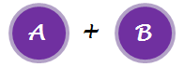

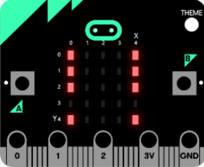

1. Tweak your code so that the time given to the user to “whack a mole” decreases when the score reaches 10 points, 20 points, 30 points etc. To start with the delay should be set to 1000ms, it should then decrease to 900ms, then 800ms, 700ms, etc. Use a variable to store the value of the delay. Initialise this variable to 1000ms.